Data Modification Problem3
- Modification Statement
INSERT INTO Location(LocNo,FacNo,LocName)
VALUES ('L108','F104','Locker Room');
- Before (8 rows)
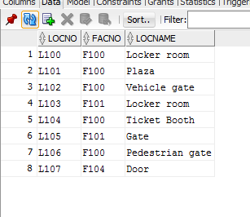
- Inserted
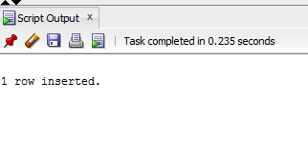
- After(9 rows)
